23CSE111

OBJECT ORIENTED PROGRAMMING

LAB MANUAL



Department of Computer and Science Engineering

Amrita School of Engineering

Amrita Vishwa Vidyapeetham, Amaravati Campus

Name:-G SAI KRISHNA

Sec:-CSE-A

Roll.No:-AV.SC.U4CSE24050

Verified By:

|  |  |  |  |  |
| --- | --- | --- | --- | --- |
| S.NO | Programs | Date | Page No | Signature |
| Week 1 |  | 27-01-2025 |  |  |
| 1 | Write the steps to download and install Java. |  |  |  |
| 2 | Write a java program to print the message “Welcome to java programming”. |  |  |  |
| 3 | Write a java program that prints student details(name, roll number and section of a student). |  |  |  |
| Week 2 |  | 3-02-2025 |  |  |
| 1 | Write a java program to calculate the area of a rectangle. |  |  |  |
| 2a) | Write a program to convert temperature from Celsius to Fahrenheit |  |  |  |
| 2b) | Write a program to convert temperature from Fahrenheit to Celsius. |  |  |  |
| 3 | Write a program to calculate the simple interest |  |  |  |
| 4 | Write a program to find the largest of three numbers using ternary operator |  |  |  |
| 5 | Write a program to find the factorial of a number |  |  |  |
|  |  |  |  |  |
| Week-3 |  | 11-02-2025 |  |  |
| 1. | Create a java program with following instructions a )create a class with name car b) Create 4 attributes name car color, car brand, fuel type, milage.  c) Create 3 methods named start, stop, services  d) Create 3objects named car1, car2, car3. e) Create a constructor which should print “welcome to car garage” |  |  |  |
| 2. | Write a java program to create a class BackAccount with two methods deposit( ) and withdraw() b) In deposit( ) whenever an amount is deposited it has to be updated with current amount b) In withdraw( ) whenever an amount is withdrawn it has to be less than current amount else print “Insufficient funds” |  |  |  |
|  |  |  |  |  |
| Week-4 |  | 02-03-2025 |  |  |
| 1. | Write a java program with class named “Book”. The class should contain various attributes such as “Title of the book , author , year of publication “. It should also contain a constructor with parameters details of the book. i.e. “ Title of the book, author and year of publication”. Display the details of two books by creating two objects. |  |  |  |
| 2. | To create a java program with class named Myclass with a staticvariable “Count” of “int type”, Initialized to 0 and a constant variable “pi” of type double initialized to 3.1415 as attributes of that class Now, define a constructor for “Myclass” that increments the “Count” variable each that an object of Myclass is created. Finally , print the final values of “Count” and “pi”variables. |  |  |  |
|  |  |  |  |  |
| Week-5 |  | 09-03-2025 |  |  |
| 1. | Create a calc using the operations including add, sub, mul, div using multilevel inheritance and display the desired output |  |  |  |
| 2. | Creating a Rental Sysytem |  |  |  |
|  |  |  |  |  |
| Week-6 |  | 16-03-2025 |  |  |
| 1. | Write a java program to create a Vehicle class with displayInfo() method , overridden in Car subclass to provide info about carcompany , model , price ,seating and petrol. |  |  |  |
| 2. | An automated admission system that verifies student eligibility for UG and PG with different criteria.  1.UG requires minimum of 60%  2.PG requires minimum of 70% |  |  |  |
| 3. | Create a calculator class with overloaded methods to perform additions 1.add two integers  2.add two double values 3.add three integers |  |  |  |
| 4. | Create a shape class with method calculateArea() that is overloaded for different shapes (eg: square, rectangle).Then create a subclass Circle that overrides calculateArea() method for Circle. |  |  |  |
|  |  |  |  |  |

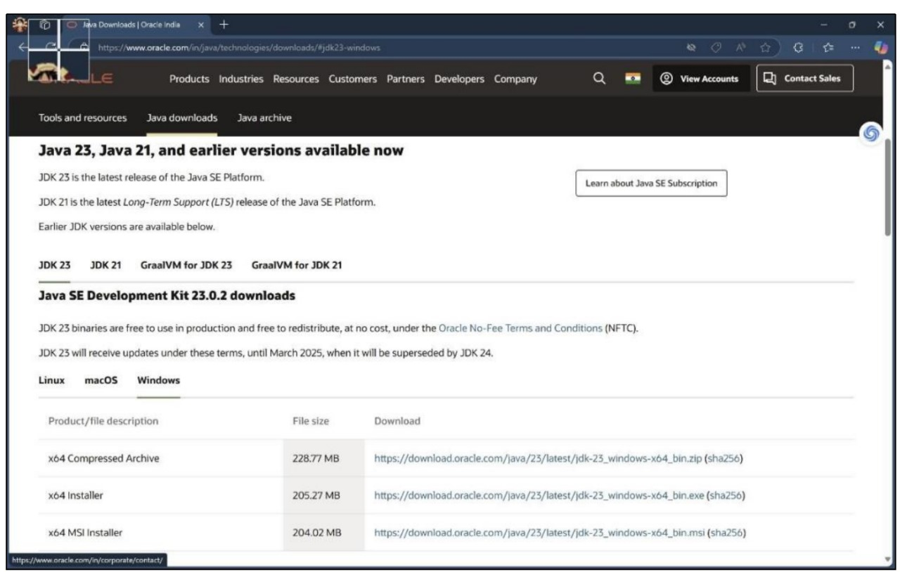 ***WEEK –1*** Task:-1) Write the steps to download and install Java. Aim: To download and install java. Procedure: i. Visit oracle.com website to download Java.

ii. Download the version which supports LTS (JDK 21) x64 installer for windows. iii. Install and copy the path.

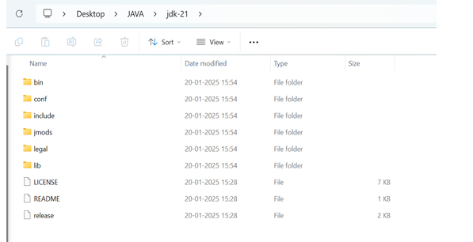

iv. Open environmental variables and add a new file with path.

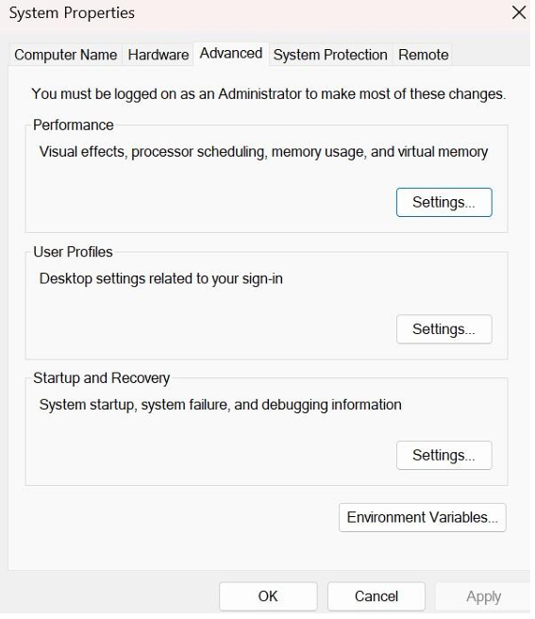

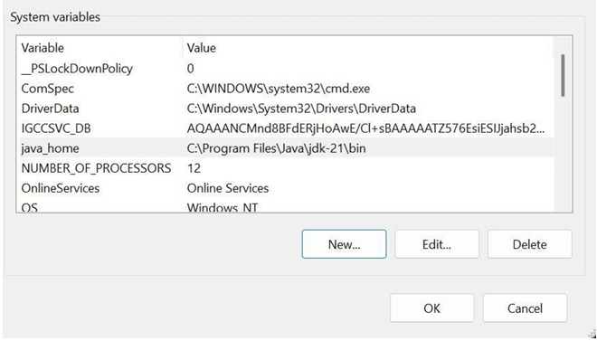

v. Verify java version in command window.

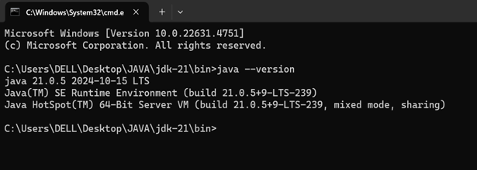

Task:-2) Write a java program to print the message “Welcome to java programming”. *Code:-* public class Main { public static void main(String[] args){ System.out.println("Welcome to java programming."); } } Output:- 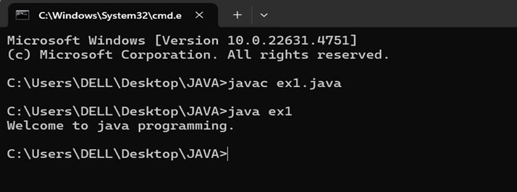

*Error:-*

|  |  |  |
| --- | --- | --- |
| S.No | Expected Error | Reason |
| 1 | ; | ; is expected at end |
| 2 | S | Capital S is expected for String and System. |

Task:-3)Write a java program that prints student details(name, roll number and section of a student).

Code: class ex2{ public static void main(String[] args){ String name = "Sai Krishna"; int rollNo = 24050; String section = "A"; System.out.println("Student Information:"); System.out.println("Name:" + name); System.out.println("Roll No:" + rollNo); System.out.println("Section:" + section);

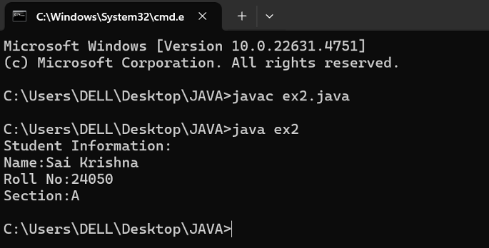 } } **Output:-**

|  |  |  |
| --- | --- | --- |
| S.No | Expected Error | Reason |
| 1 | S | Capital S is expected for String and System. |

**WEEK-2**

**1)JAVA PROGRAM TO CALCULATE THE AREA OF THE RECTANGLE:**

**CODE:**

import java.util.Scanner;

public class area {

public static void main(String[] args) {

Scanner scanner = new Scanner(System.in);

System.out.print("Enter the length of the rectangle: ");

double length = scanner.nextDouble();

System.out.print("Enter the width of the rectangle: ");

double width = scanner.nextDouble();

double area = length * width;

System.out.println("The area of the rectangle is: " + area);

scanner.close();

}

}

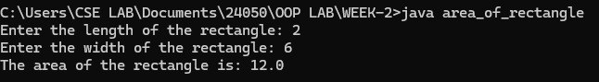**OUTPUT:**

Error:-

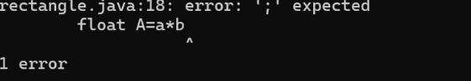

|  |  |  |
| --- | --- | --- |
| S.No | Expected Error | Reason |
| 1 | ; | That is  semicolon( ; )  is not present at the  end of the  expression. |

**2)**

**A)JAVA PROGRAM TO CONVERT TEMPERATURE FROM CELCIUS TO FAHRENHEIT:**

**CODE:**

import java.util.Scanner;

public class celcius_to_fahrenheit {

public static void main(String[] args) {

Scanner scanner = new Scanner(System.in);

System.out.print("Enter temperature in Celsius: ");

double celsius = scanner.nextDouble();

double fahrenheit = (celsius * 9/5) + 32;

System.out.println(celsius + " Celsius is equal to " + fahrenheit + " Fahrenheit.");

scanner.close();

}

}

**OUTPUT:**



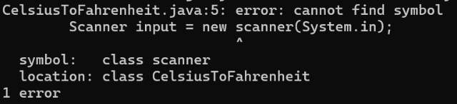Error:-

|  |  |  |
| --- | --- | --- |
| S.No | Expected Error | Reason |
| 1 | S | Capital S is expected for String and System. |

**B)JAVA PROGRAM TO CONVERT FAHRENHEIT TO CELCIUS :**

**CODE:**

import java.util.Scanner;

public class ftoc {

public static void main(String[] args) {

Scanner scanner = new Scanner(System.in);

System.out.print("Enter temperature in Fahrenheit: ");

double fahrenheit = scanner.nextDouble();

double celsius = (fahrenheit - 32) * 5 / 9;

System.out.println(fahrenheit + " Fahrenheit is equal to " + celsius + " Celsius.");

scanner.close();

}

}

**OUTPUT:**



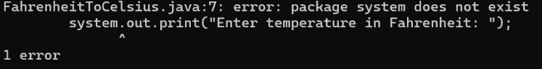Error:-

|  |  |  |
| --- | --- | --- |
| S.No | Expected Error | Reason |
| 1 | S | Capital S is expected for String and System. |

**3)JAVA PROGRAM TO CALCULATE THE SIMPLE INTEREST:**

**CODE:**

import java.util.Scanner;

public class SimpleInterest {

public static void main(String[] args) {

Scanner scanner = new Scanner(System.in);

System.out.print("Enter the principal amount: ");

double principal = scanner.nextDouble();

System.out.print("Enter the rate of interest (in %): ");

double rate = scanner.nextDouble();

System.out.print("Enter the time period (in years): ");

double time = scanner.nextDouble();

double simpleInterest = (principal * rate * time) / 100;

System.out.println("The simple interest is: " + simpleInterest);

scanner.close();

}

}

**OUTPUT:**

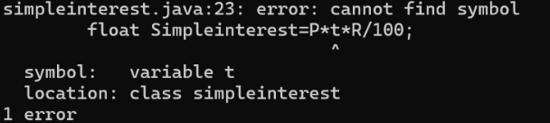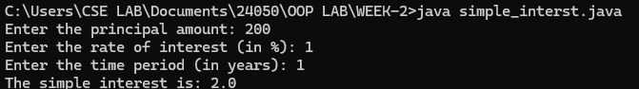Error:-

|  |  |  |
| --- | --- | --- |
| S.No | Expected Error | Reason |
| 1 | T | Capital T is expected for String and System. |

**4)JAVA PROGRAM TO FIND THE LARGEST AMONG THREE NUMBER USING TERNARY OPERATOR:**

**CODE:**

import java.util.Scanner;

public class largest3 {

public static void main(String[] args) {

Scanner scanner = new Scanner(System.in);

System.out.print("Enter the first number: ");

int num1 = scanner.nextInt();

System.out.print("Enter the second number: ");

int num2 = scanner.nextInt();

System.out.print("Enter the third number: ");

int num3 = scanner.nextInt();

int largest = (num1 >= num2 && num1 >= num3) ? num1 : (num2 >= num1 && num2 >= num3) ? num2 : num3;

System.out.println("The largest number is: " + largest);

scanner.close();

}

}

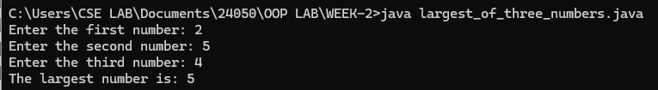**OUTPUT:**

**Error:-**

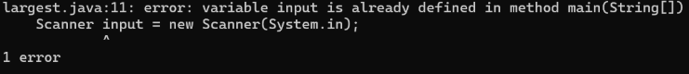

|  |  |  |
| --- | --- | --- |
| S.No | Expected Error | Reason |
| 1 | main(String []). | Variable input is already defines in method main(String []). |

**5)JAVA PROGRAM TO FIND FACTORIAL OF A NUMBER:**

**CODE:**

import java.util.Scanner;

public class factorial {

public static void main(String[] args) {

Scanner scanner = new Scanner(System.in);

System.out.print("Enter a number to find its factorial: ");

int number = scanner.nextInt();

long factorial = 1;

if (number < 0) {

System.out.println("Factorial is not defined for negative numbers.");

} else {

for (int i = 1; i <= number; i++) {

factorial *= i;

}

System.out.println("The factorial of " + number + " is: " + factorial);

}

scanner.close();

}

}

**OUTPUT:**

Error:- 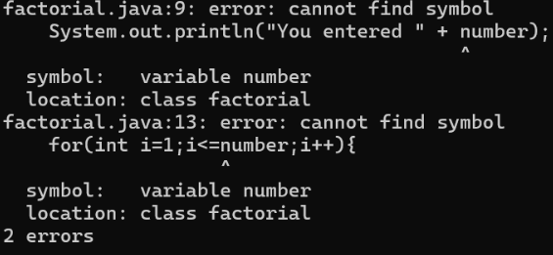

WEEK – 3

1) Create the java program with the following instructions i) Create a class with name Car ii) Create 4 attributes named Car_Color , Car_brand, fuel_type, mileage iii) Create 3 method named Start( ) , Stop( ), Service( ) iv) Create 3 objects Car1 , Car2 , Car3 v) Create a constructor which should print “Welcome to Car Garage” public class Car{

    public String carColor;

    private String carBrand;

    private String fuelType;

    public int mileage;

    Car(String carColor , String carBrand , String fuelType , int mileage){

    this.carColor =  carColor;

    this.carBrand = carBrand;

    this.fuelType = fuelType;

    this.mileage = mileage;

    System.out.println(carColor + " " + carBrand + " " + fuelType + " " +

mileage);

    }

    public void Start(){

    System.out.println("The car has just started");

    }

    public void Stop(){

    System.out.println("The car has just stopped");

    }

    public void Service(){

    System.out.println("The car is in good condition");

     }

    public static void main(String[] args){

   Car Car1 = new Car("Black","BMW","Petrol",20);

   Car Car2 = new Car("White","AUDI","Diesel",17);

   Car Car3 = new Car("Red","BENZ","Petrol",16);

   Car1.Start();

   }

   }

OUTPUT:-

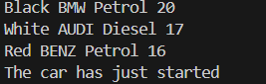

*Error:-*

|  |  |  |
| --- | --- | --- |
| S.No | Expected Error | Reason |
| 1 | } | } is expected at end of the class |
| 2 | Setting the parameters inside the constructor | We cannot pass the values inside constructor without setting them first |

Class Diagram:

|  |
| --- |
| Car |
| + carColor : String - carBrand : String - fuelType : String + mileage : int |
| + Car() : void + Start( ) : void + Stop( ) : void + Service( ) : void |

2)Write a java program to create a class BackAccount with two methods deposit( ) and withdraw( ) i) In deposit( ) whenever an amount is deposited it has to be updated with current amount ii) In withdraw( ) whenever an amount is withdrawn it has to be less than current amount else print “Insufficient funds”. Code: - public class BankAccount {

    private String Name;

    private int AccNo, CurrBal;

    public BankAccount(String Name, int AccNo, int CurrBal) {

        this.Name = Name;

        this.AccNo = AccNo;

        this.CurrBal = CurrBal;

        System.out.println("The customer is: " + this.Name);

    }

    public int deposit(int dAmt) {

        CurrBal += dAmt;

        return CurrBal;

    }

    public void withdraw(int wAmount) {

        if (wAmount <= CurrBal) {  // Allowing withdrawal if balance is equal

            CurrBal -= wAmount;

            System.out.println("Remaining Balance: " + CurrBal);

        } else {

            System.out.println("Insufficient funds");

        }

    }

    public static void main(String[] args) {

        BankAccount SaiKrishna = new BankAccount("SaiKrishna", 2000, 15000);

        SaiKrishna.withdraw(13000);  // Should print "Insufficient funds"

        SaiKrishna.withdraw(1900);   // Should print remaining balance

        int FinalAmount = SaiKrishna.deposit(10000);

        System.out.println("Final Balance: " + FinalAmount);

    }

}

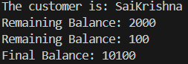OUTPUT:-

*Error:-*

|  |  |  |
| --- | --- | --- |
| S.No | Expected Error | Reason |
| 1 | } | } is expected at end of the class |
| 2 | Setting the parameters inside the constructor | We cannot pass the values inside constructor without setting them first |

Class Diagram:-

|  |
| --- |
| BankAccount |
| - Name : String - AccNo : String - CurrBal: String |
| + BankAccount( ) : void + deposit( ) : int + withdraw( ) : void |

WEEK – 4 1) Write a java program with class named “Book”. The class should contain various attributes such as “Title of the book , author , year of publication “. It should also contain a constructor with parameters details of the book. i.e. “ Title of the book, author and year of publication”. Display the details of two books by creating two objects. Code: import java.util.Scanner;

class book{

 public String title;

 public String author;

 public int year;

 book(String title,String author, int year){

  this.title=title;

  this.author=author;

  this.year=year;

 }

 public void display(){

  System.out.println("Title of the book is: "+title);

  System.out.println("Author of the book is: "+author);

  System.out.println("Year of publishion of the book is: "+year);

 }

 public static void main(String[] args){

  Scanner scan=new Scanner(System.in);

System.out.println("Enter name of the book:");

String title=scan.nextLine();

System.out.println("Enter author of the book:");

String author=scan.nextLine();

System.out.println("Enter year of publishion of the book:");

int year=scan.nextInt();

book third=new book(title,author,year);

third.display();

book first=new book("Disha 144","Disha",2024);

book second=new book("Disha 168","Disha ",2025);

 first.display();

second.display();

}

}

Output:

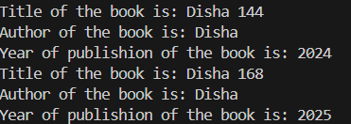

Errors :

|  |  |  |
| --- | --- | --- |
| S.No. | Expected Error | Reason |
| 1 | Setting the parameters inside the constructor | We cannot pass the values inside constructor without setting them first |
| 2 | } | Ending the class and main method is required |

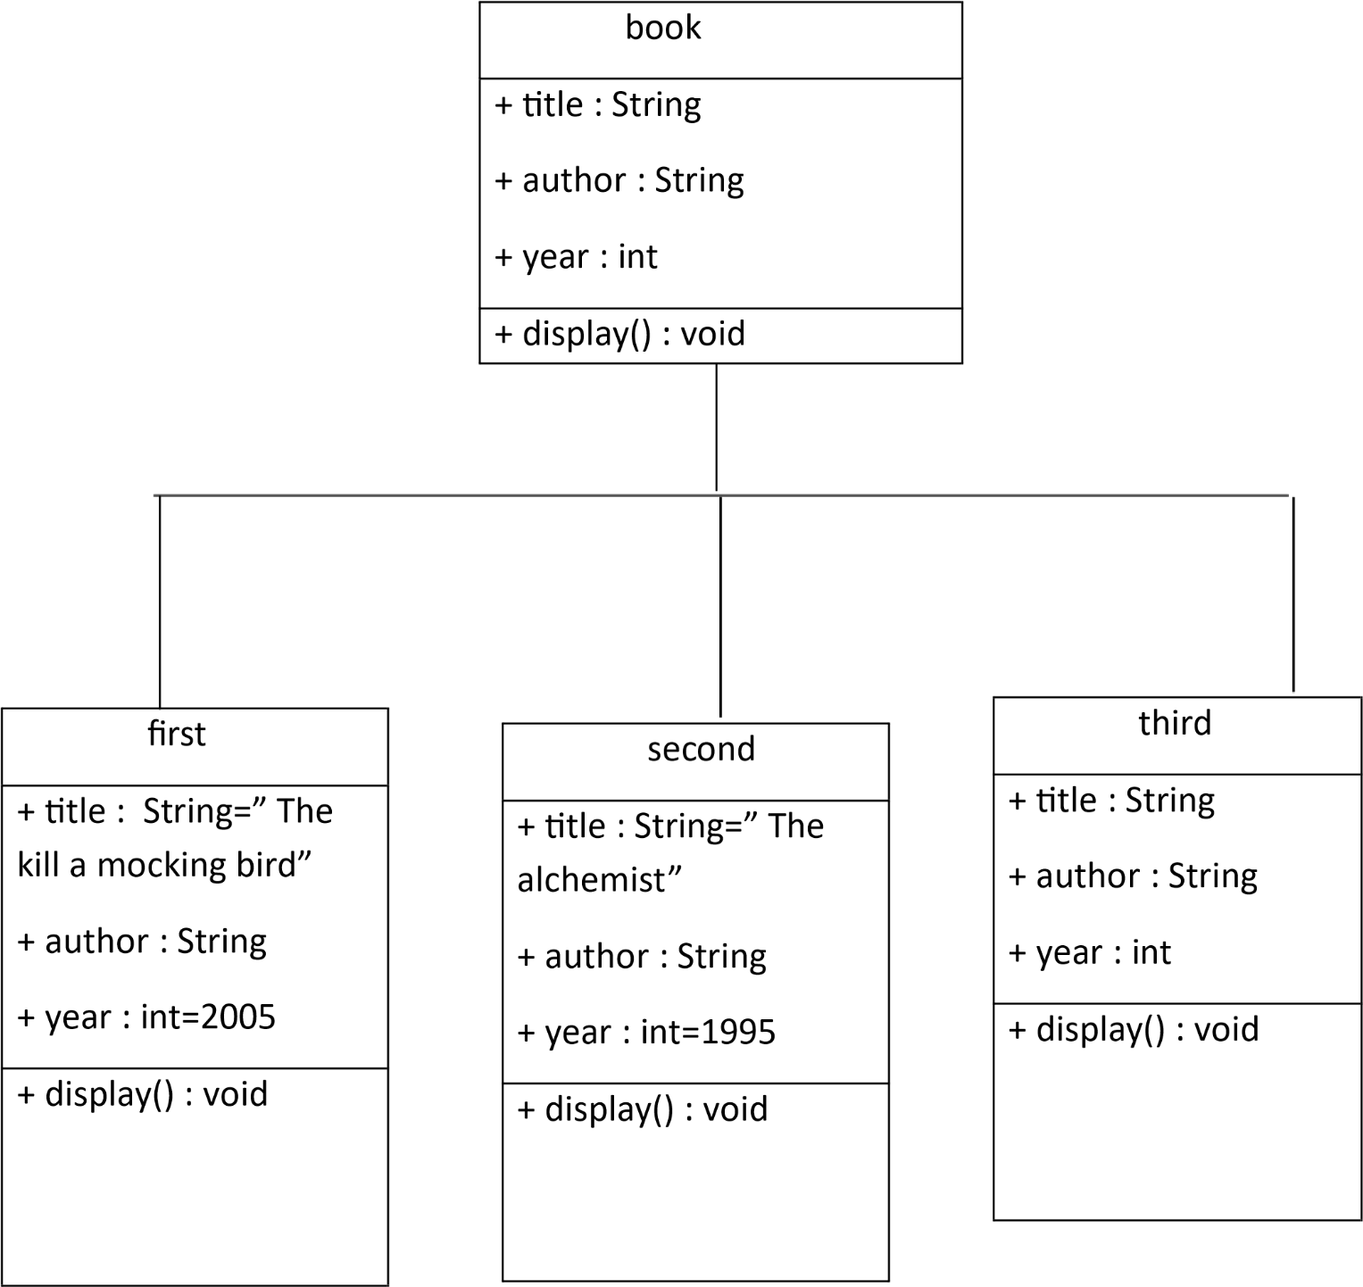

2) To create a java program with class named Myclass with a static variable “Count” of “int type”, Initialized to 0 and a constant variable “pi” of type double initialized to 3.1415 as attributes of that class Now, define a constructor for “Myclass” that increments the “Count” variable each that an object of Myclass is created. Finally , print the final values of “Count” and “pi” variables.

**Code:-**

class myclass{

    static int count=0;

     final double pi=3.1415;

    myclass(){

    count++;

    }

    void display(){

    System.out.println("The value of pi is: "+ pi);

    }

    public static void main(String[] args){

    myclass obj1=new myclass();

    myclass obj2=new myclass();

    myclass obj3=new myclass();

    int fc=count;

    System.out.println("Total number of objects created is: "+fc);

    obj1.display();

    obj2.display();

    obj3.display();

    }

    }

**Output: -**

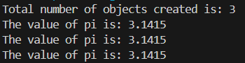

**Errors :**

|  |  |  |
| --- | --- | --- |
| S.No. | Expected Error | Reason |
| 1 | .variable | We must mention variable name to call the variable |
| 2 | static | Static variables contain only one value |

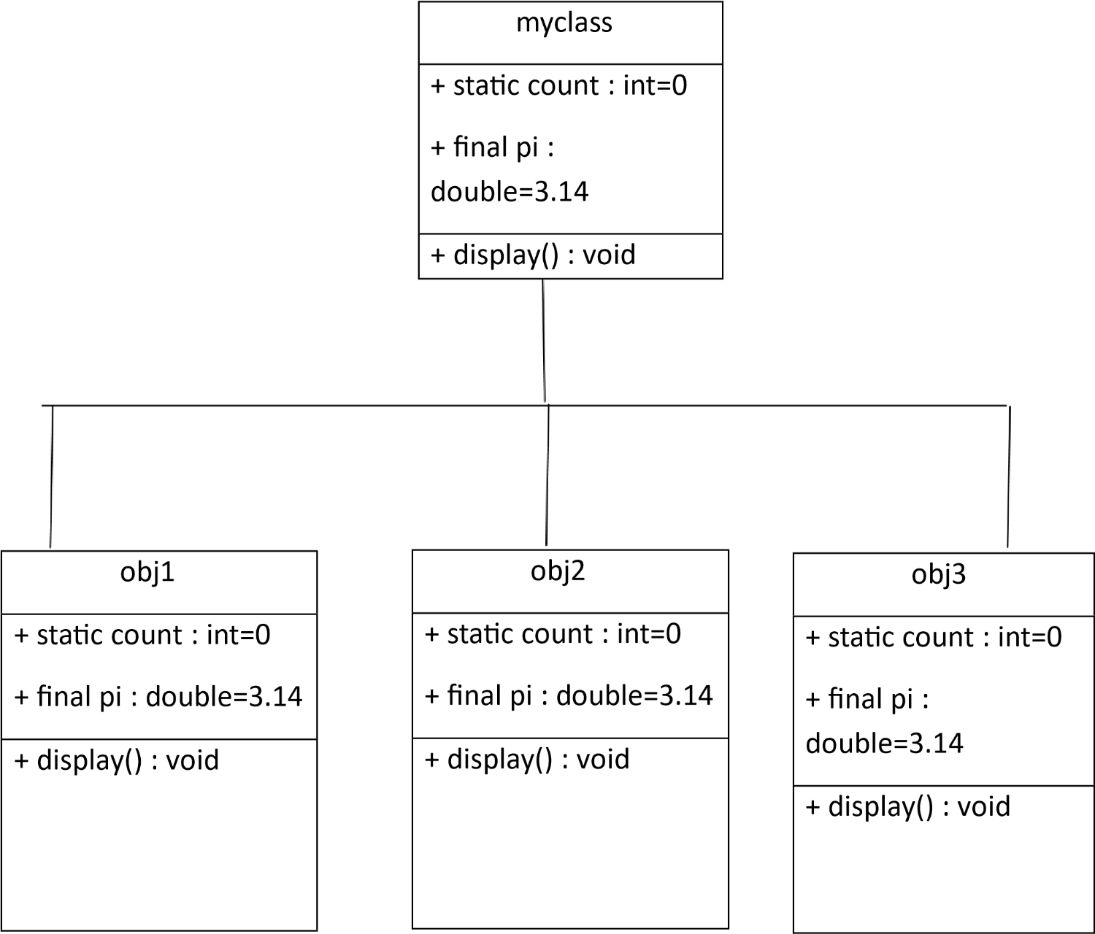

WEEK-5

1) Create a calc using the operations including add, sub, mul, div using multilevel inheritance and display the desired output. CODE:- public class bcalc {

int a, b;

int sum, diff;

bcalc(int a, int b) {

this.a = a;

this.b = b;

}

public void add() {

diff = a - b;

sum = a + b;

System.out.println("Difference: " + diff);

System.out.println("Sum: " + sum);

}

}

class acalc extends bcalc {

int mul;

acalc(int a, int b) {

super(a, b);

}

public void mult() {

mul = a * b;

System.out.println("Multiplication: " + mul);

}

}

class aacalc extends acalc {

float div;

aacalc(int a, int b) {

super(a, b);

}

public void divi() {

if (b != 0) { // Check to avoid division by zero operators {

div = (float) a / b;

System.out.println("Division: " + div);

} else {

System.out.println("Division by zero error!");

}

}

}

class ocalc {

public static void main(String[] args) {

aacalc c = new aacalc(10, 2);

c.divi();

c.mult();

c.add();

}

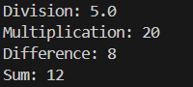} OUTPUT:-

ERRORS:-

|  |  |  |
| --- | --- | --- |
| S.No. | Expected Error | Reason |
| 1 | .variable | We must mention variable name to call the variable |
| 2 | static | Static variables contain only one value |

CLASS DIAGRAMS:-

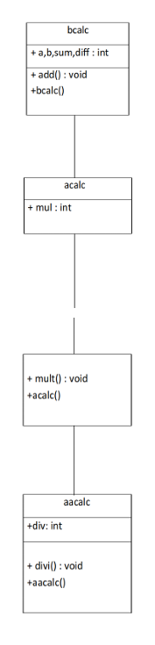

2) A vehicle rental company wants to develop a system that maintains information about different types of vehicles available for rent. The company rents out cars and bikes and they need a program to store details about each vehicle such as brand and speed cars should have an additional properties(attributes)- no.of doors , seating capacity bikes should have a property indicating whether they have gears or not the system should also include a function to display details about each vehicle and indicate when a vehicle is starting each class should have a constructor .

a) which oops concept is used in the above program ? Explain why it is useful in this scenario

b)If the company decides to add a new type of vehicle truck how would u modify the above program

1) truck should include an additional property called capacity(in tons) 2)create a show truck details method() to display the trucks capacity 3)write a constructor for truck that initializes all the properties c)Implement the truck class and update the main method to create the truck object and also create an object for car and bike subclass. Finally display its details

CODE:-

public class Vehicle {

    String brand;

    int speed;

    Vehicle(String brand, int speed) {

    this.brand = brand;

    this.speed = speed;

    }

    void displayDetails() {

    System.out.println("Brand: " + brand);

    System.out.println("Speed: " + speed + " km/h");

    }

    void startVehicle() {

    System.out.println(brand + " is starting...");

    }

    }

    // Car subclass

    class Car extends Vehicle {

    int noOfDoors;

    int seatingCapacity;

    Car(String brand, int speed, int noOfDoors, int seatingCapacity) {

    super(brand, speed);

    this.noOfDoors = noOfDoors;

    this.seatingCapacity = seatingCapacity;

    }

    @Override

    void displayDetails() {

    super.displayDetails();

    System.out.println("Number of Doors: " + noOfDoors);

    System.out.println("Seating Capacity: " + seatingCapacity);

    }

    }

    // Bike subclass

    class Bike extends Vehicle {

    boolean hasGears;

    Bike(String brand, int speed, boolean hasGears) {

    super(brand, speed);

    this.hasGears = hasGears;

    }

    @Override

    void displayDetails() {

    super.displayDetails();

    System.out.println("Has Gears: " + (hasGears ? "Yes" : "No"));

    }

    }

    // Truck subclass

    class Truck extends Vehicle {

    double capacity;

    Truck(String brand, int speed, double capacity) {

    super(brand, speed);

    this.capacity = capacity;

    }

    void showTruckDetails() {

    System.out.println("Truck Capacity: " + capacity + " tons");

    }

    @Override

    void displayDetails() {

    super.displayDetails();

    showTruckDetails();

    }

    }

    // Main class

 class VehicleRentalSystem {

    public static void main(String[] args) {

    Car car = new Car("Toyota", 150, 4, 5);

    Bike bike = new Bike("Yamaha", 120, true);

    Truck truck = new Truck("Volvo", 100, 15.5);

    System.out.println("Car Details:");

    car.displayDetails();

    car.startVehicle();

    System.out.println();

    System.out.println("Bike Details:");

    bike.displayDetails();

    bike.startVehicle();

    System.out.println();

    System.out.println("Truck Details:");

    truck.displayDetails();

    truck.startVehicle();

    }}

 OUTPUT:-

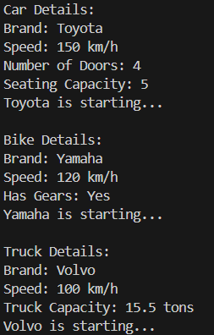

ERRORS:-

|  |  |  |
| --- | --- | --- |
| S.No. | Expected Error | Reason |
| 1 | .variable | We must mention variable name to call the variable |
| 2 | static | Static variables contain only one value |

CLASS DIAGRAM:-

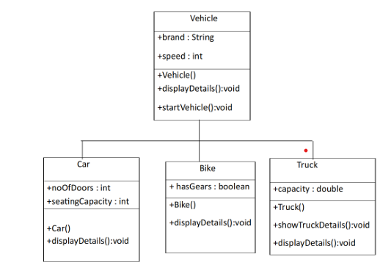

WEEK-6

1. Write a java program to create a Vehicle class with displayInfo() method overridden in Car subclass to provide info about car company , model , price, seating and petrol.

CODE:-

public class vehicles {

    void displayinfo() {

        System.out.println("This is a vehicle");

    }

}

class Car extends vehicles {

    String Name, Model, Capacity;

    int Price;

    boolean Petrol;

    Car(String Name, String Model, String Capacity, int Price, boolean Petrol) {

        this.Name = Name;

        this.Model = Model;

        this.Capacity = Capacity;

        this.Price = Price;

        this.Petrol = Petrol;

    }

    @Override

    public void displayinfo() {

        System.out.println("Car name is: " + Name);

        System.out.println("The model is: " + Model);

        System.out.println("The price of the car is: " + Price);

        System.out.println("The seating capacity of the car is: " + Capacity);

        System.out.println("Is it petrol? " + Petrol);

    }

}

 class Main {

    public static void main(String[] args) {

        Car c1 = new Car("Toyota", "Sedan", "5-Seater", 4500, true);

        c1.displayinfo();

    }}

OUTPUT:-

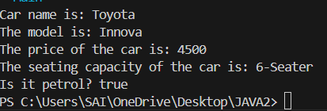

ERRORS:-

|  |  |  |
| --- | --- | --- |
| **S.No** | **Expected Error** | **Reason** |
| **1** | Setting the parameters inside the constructor | We cannot pass the values inside constructor without setting them first |
| **2** | } | Ending the class and main method is required |

CLASS DIAGRAM:-

|  |
| --- |
| Vehicle |
| +displayInfo(): void |

|  |
| --- |
| car |
| +displayInfo(): void |

2. A college is developing automated admission system that verifies students eligibility for UG and PG programs .Each program has different eligibility criteria based on the students percentage in their previous qualification.

* UG admission require minimum 60%
* PG admission require minimum 70%

CODE:-

import java.util.Scanner;

class College {

    String name;

    int qualification;

    int percentage;

    // Constructor

    College(String name, int qualification, int percentage) {

        this.name = name;

        this.qualification = qualification;

        this.percentage = percentage;

    }

    // Default Eligibility method

    public void Eligibility() {

        System.out.println("Name: " + name + ", Qualification: " + qualification + ", Percentage: " + percentage);

        System.out.println("The candidate is a fluke");

    }

}

class UG extends College {

    UG(String name, int qualification, int percentage) {

        super(name, qualification, percentage);

    }

    @Override

    public void Eligibility() {

        System.out.println("Name: " + name + ", Qualification: " + qualification + ", Percentage: " + percentage);

        System.out.println("The candidate is eligible for UG");

    }

}

class PG extends College {

    PG(String name, int qualification, int percentage) {

        super(name, qualification, percentage);

    }

    @Override

    public void Eligibility() {

System.out.println("Name: " + name + ", Qualification: " + qualification + ", Percentage: " + percentage);

        System.out.println("The candidate is eligible for PG");

    }

}

public class Main {

    public static void main(String[] args) {

        Scanner input = new Scanner(System.in);

        // Taking inputs

        System.out.println("Enter your name:");

        String name = input.nextLine();

        System.out.println("Enter your qualification (e.g., 12 for high school, 10 for 10th, etc.):");

        int qualification = input.nextInt();

        System.out.println("Enter your percentage:");

        int percentage = input.nextInt();

        // Close scanner

        input.close();

        // Logic to check eligibility

        College candidate;

        if (percentage >= 70) {

            candidate = new PG(name, qualification, percentage);

        } else if (percentage >= 60) {

            candidate = new UG(name, qualification, percentage);

        } else {

            candidate = new College(name, qualification, percentage);

        }

        candidate.Eligibility();``

    }

}

OUTPUT:-

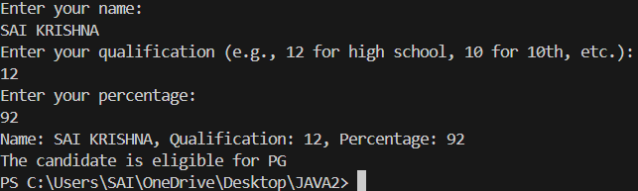

Class Diagram:-

|  |
| --- |
| **adm** |
| elg():void |

|  |  |
| --- | --- |
| ug | pg |
| +elg():void | +elg():void |

ERROR:-

|  |  |  |
| --- | --- | --- |
| **S.No** | **Expected Error** | **Reason** |
| **1** | Setting the parameters inside the constructor | We cannot pass the values inside constructor without setting them first |
| **2** | } | Ending the class and main method is required |

3. Create a calculator class with overloaded methods to perform additions

1.add two integers

2.add two double values

3.add three integers

CODE:-

public class Calculator{

    // Method to add two integers

    public int add(int a, int b) {

        return a + b;

    }

    // Method to add two tuples (represented as arrays)

    public int add(int[] tuple1, int[] tuple2) {

        int sum = 0;

        for (int i = 0; i < tuple1.length; i++) {

            sum += tuple1[i] + tuple2[i];

        }

        return sum;

    }

    // Method to add three integers

    public int add(int a, int b, int c) {

        return a + b + c;

    }

    public static void main(String[] args) {

        Calculator calc = new Calculator();

        // Adding two integers

        int result1 = calc.add(10, 20);

        System.out.println("Addition of two integers: " + result1);

        // Adding two tuples (arrays)

        int[] tuple1 = {1, 2};

        int[] tuple2 = {3, 4};

        int result2 = calc.add(tuple1, tuple2);

        System.out.println("Addition of two tuples: " + result2);

        // Adding three integers

        int result3 = calc.add(5, 10, 15);

        System.out.println("Addition of three integers: " + result3);

    }

}

OUTPUT:-

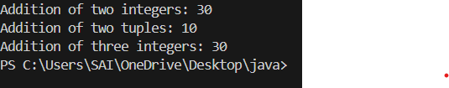

CLASS DIAGRAM:-

|  |
| --- |
| cal |
| +add(int a,int b):int  +add(double a,double b):double  +add(int a,int b,int c):int |

ERRORS:-

|  |  |  |
| --- | --- | --- |
| **S.No** | **Expected Error** | **Reason** |
| **1** | Setting the parameters inside the constructor | We cannot pass the values inside constructor without setting them first |
| **2** | } | Ending the class and main method is required |

4. Create a shape class with method calculateArea() that is overloaded for different shapes (eg: square, rectangle).Then create a subclass Circle that overrides calculateArea() method for Circle.

CODE:-

public class Shape {

    public double areaOfSquare(double side) {

        return side * side;

    }

    public double areaOfRectangle(double length, double width) {

        return length * width;

    }

    public double areaOfCircle(double radius) {

        return 3.14 * radius * radius;

    }

    public static void main(String[] args) {

        Shape shape = new Shape();

        double square = shape.areaOfSquare(5);

        System.out.println("Area of a square: " + square);

        double rectangle = shape.areaOfRectangle(10, 20);

        System.out.println("Area of a rectangle: " + rectangle);

        double circle = shape.areaOfCircle(12);

        System.out.println("Area of a circle: " + circle);

    }

}

OUTPUT:-

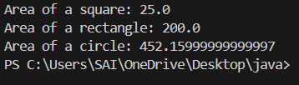

CLASS DIAGRAM:-

|  |
| --- |
| shape |
| +calarea(float side):float  +calarea(float l,float b):float  +calarea(float c):float |

|  |
| --- |
| Circle |
| +calarea(double r):double |

ERRORS:-

|  |  |  |
| --- | --- | --- |
| **S.No** | **Expected Error** | **Reason** |
| **1** | Setting the parameters inside the constructor | We cannot pass the values inside constructor without setting them first |
| **2** | } | Ending the class and main method is required |